Assignment 1

* **Creation of Database (Relational and No-SQL)**

1. Create MySQL DB Instance and Connect MySQL DB instance.

**Synopsis:**

Create a RDS and an EC2 Linux Server Instance. Connect the EC2 Instance to the RDS created. Create a Database and Table. Insert few records into the Table then read the records inserted and verify.

1. How to create Dynamo DB table and Write Data in table.

Steps to create RDMS:

1. Search RDS in Search bar. Then Click on Create Database.

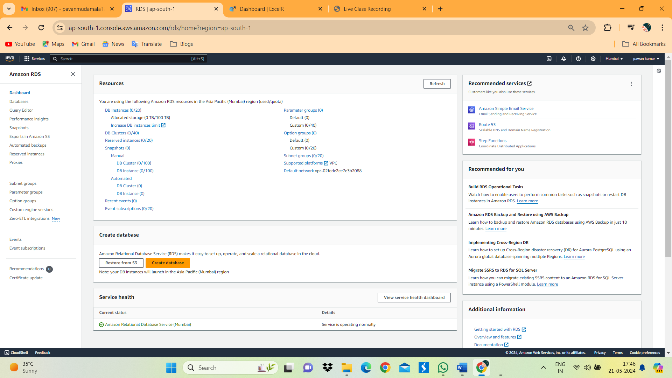

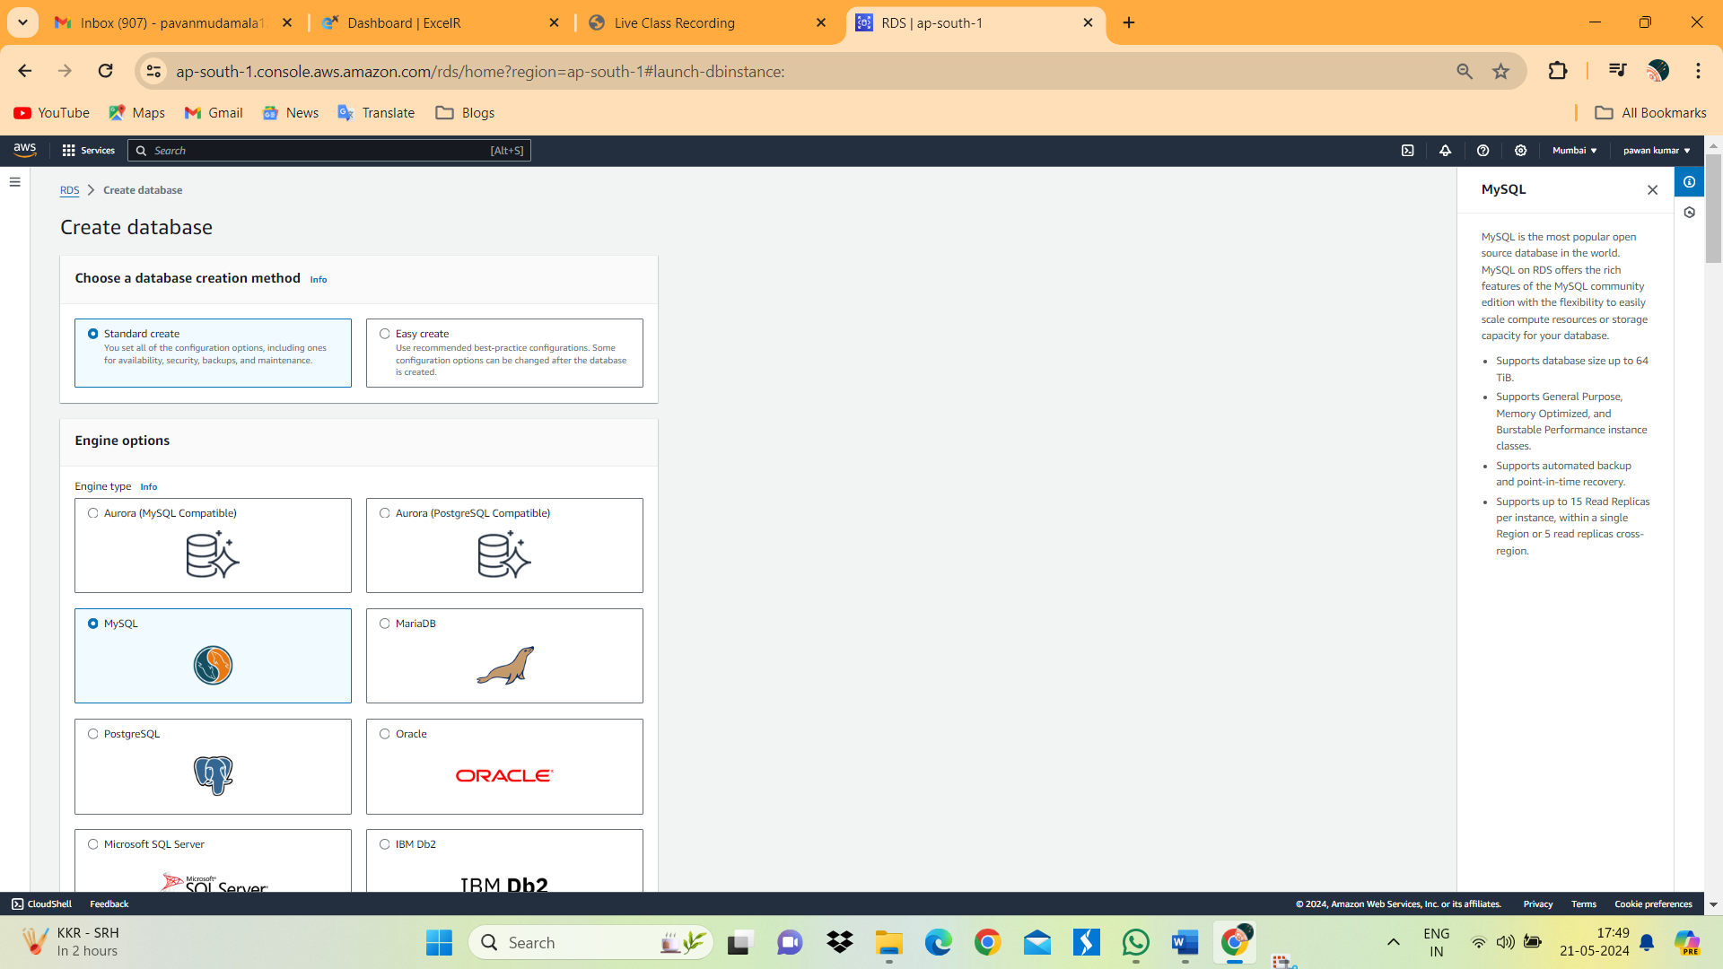

1. Select MYSQL Version Default and select Free tier.

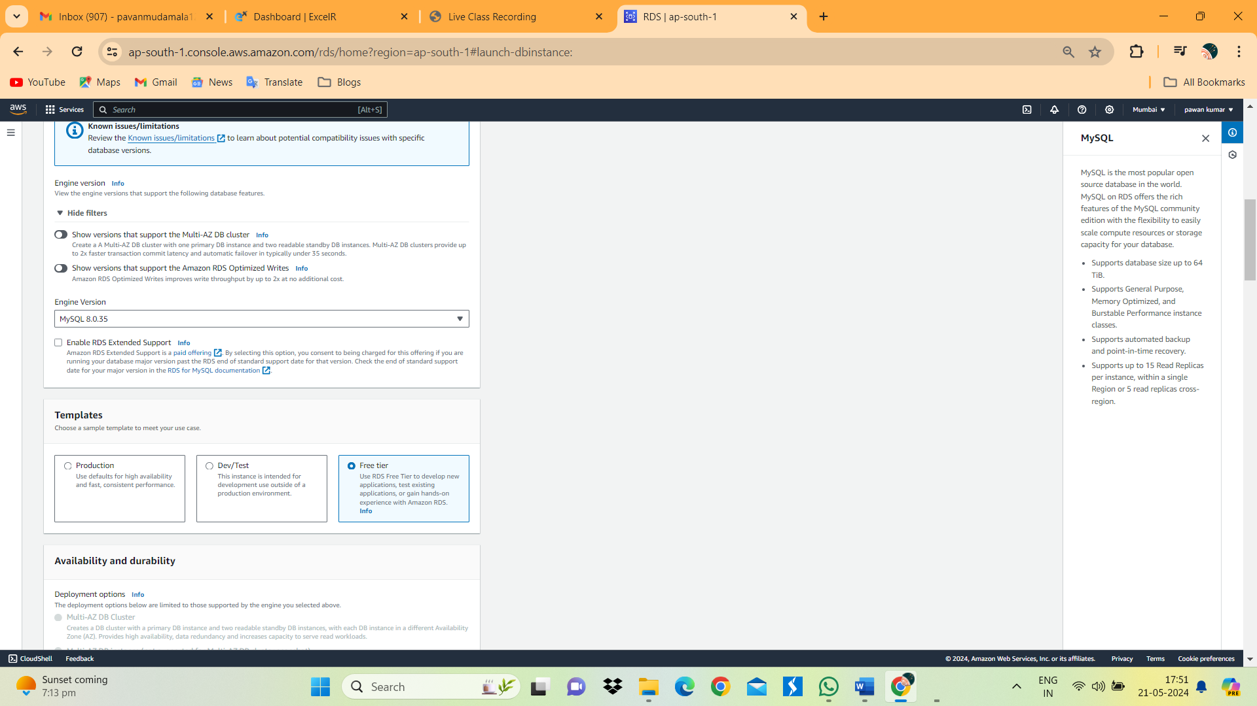

1. Give Database name ExcelR-DB user name as admin and give to password.

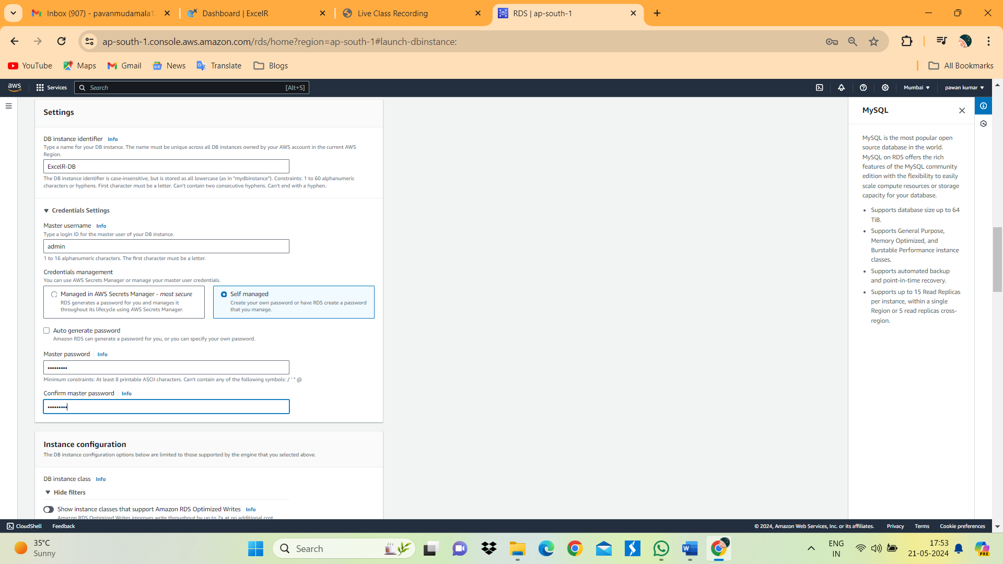

1. Select Don’t select EC2 instance. VPC Default. Select Public access Yes.

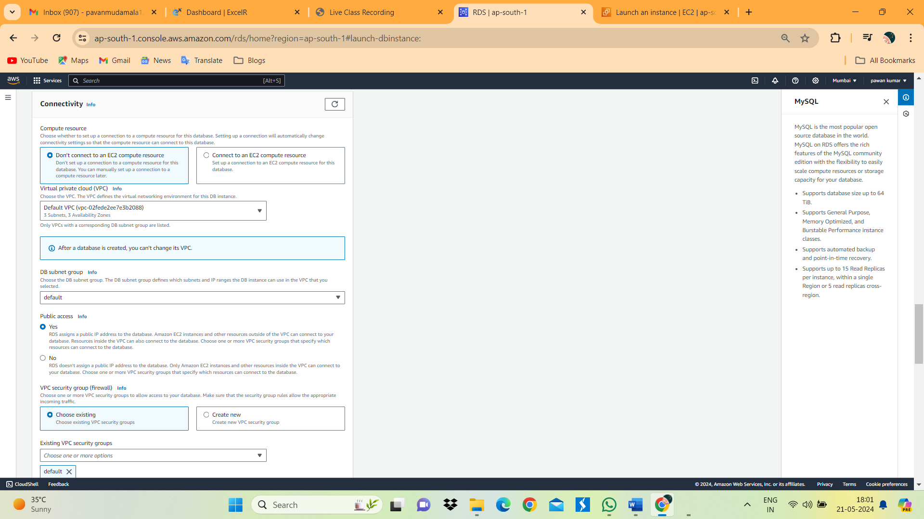

1. Click on create DataBase.

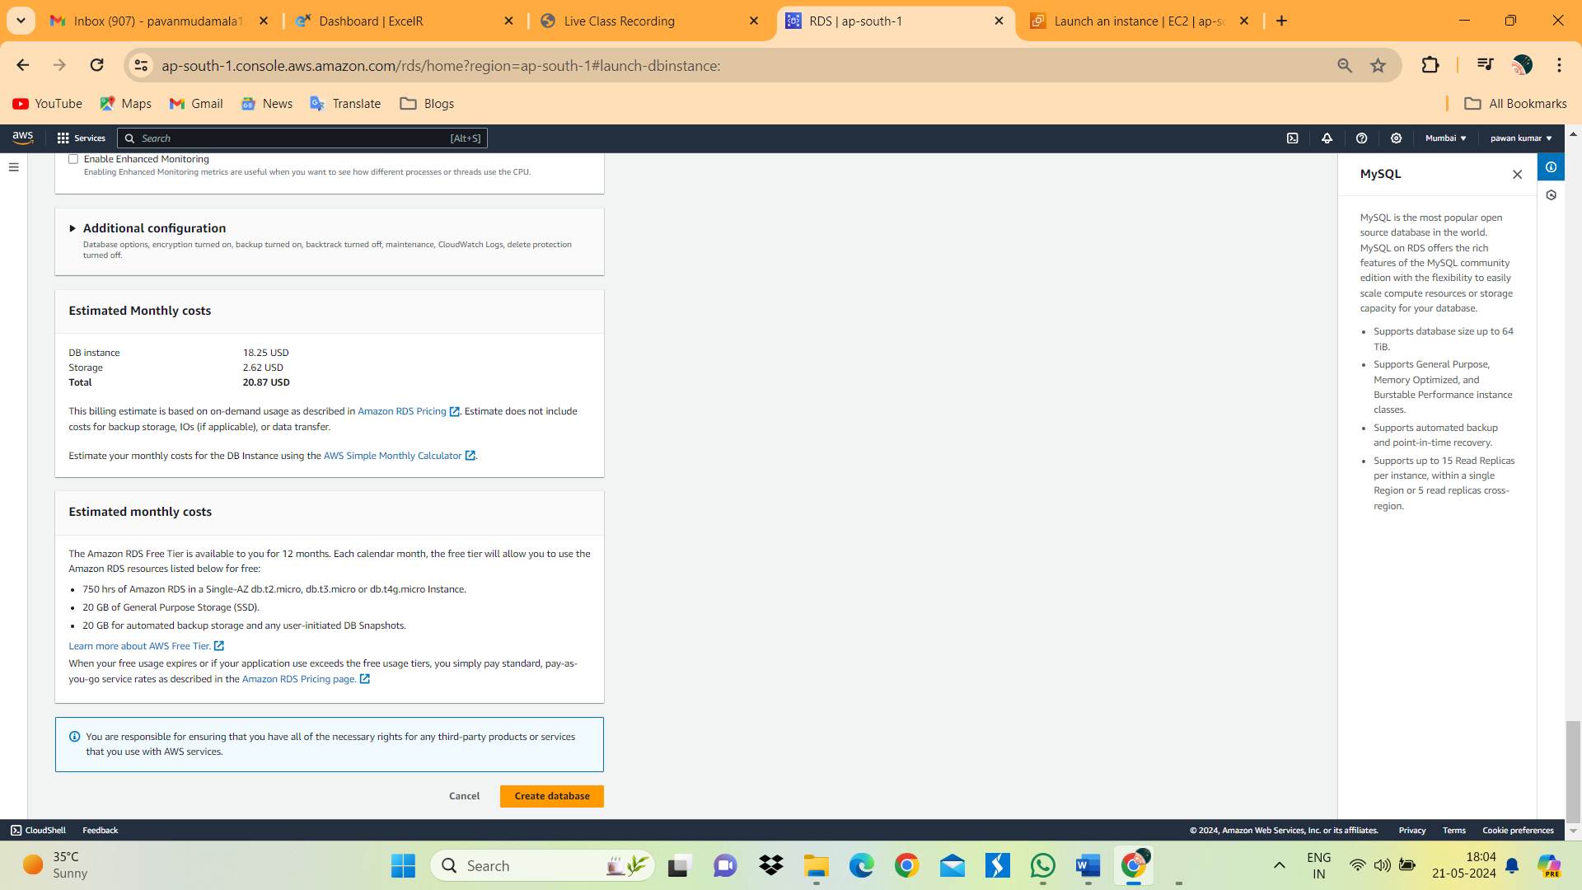

1. Below image we can see the MYSQL Database.

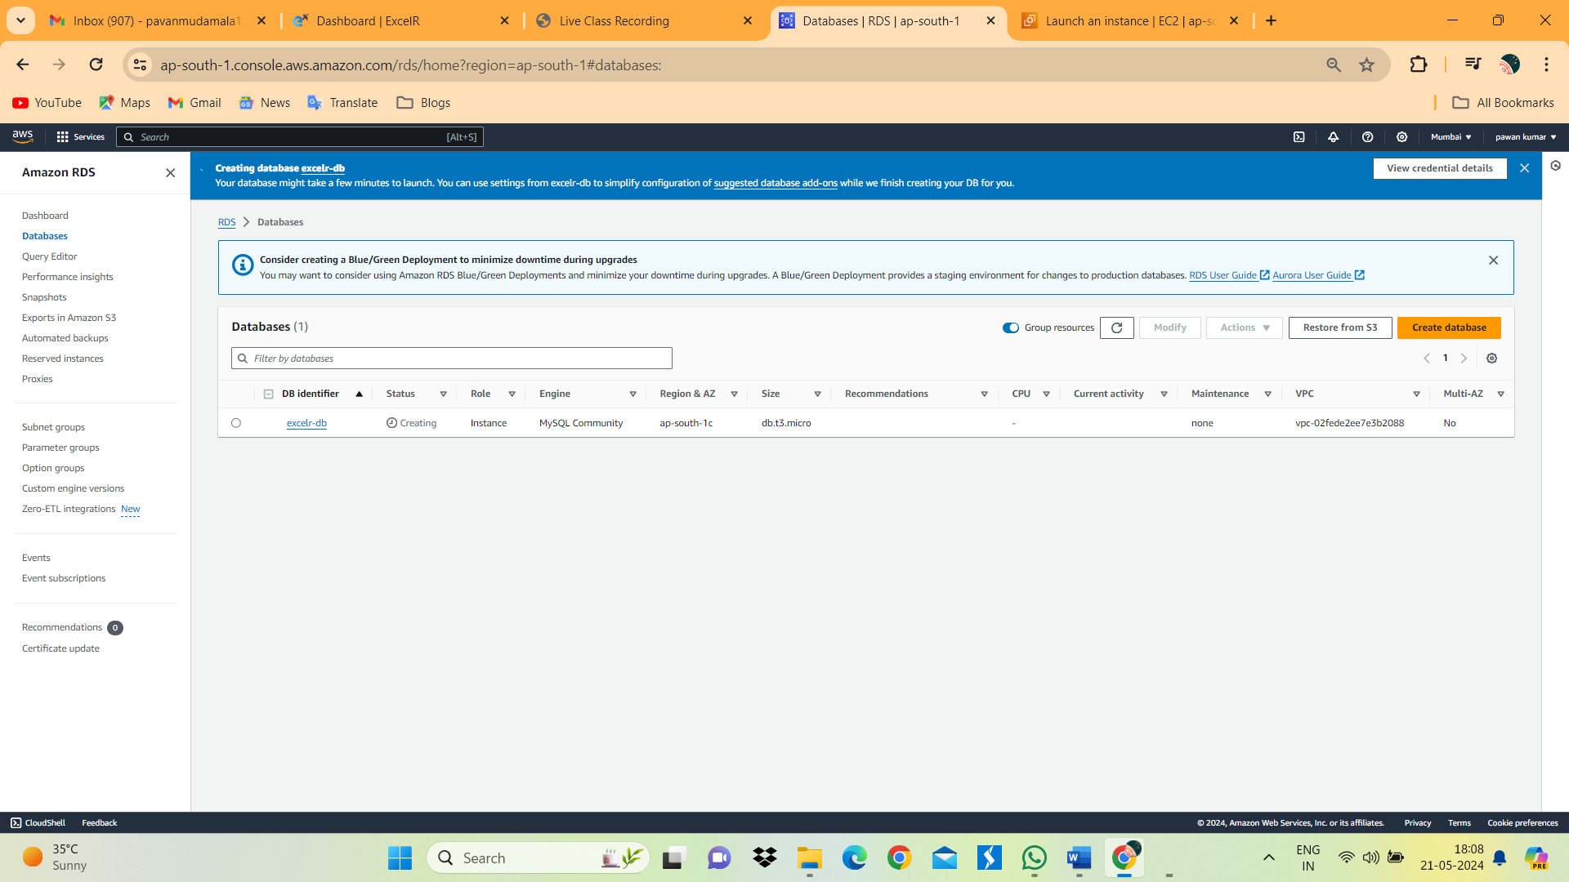

1. Launch New EC2 Linux Ubuntu instance.

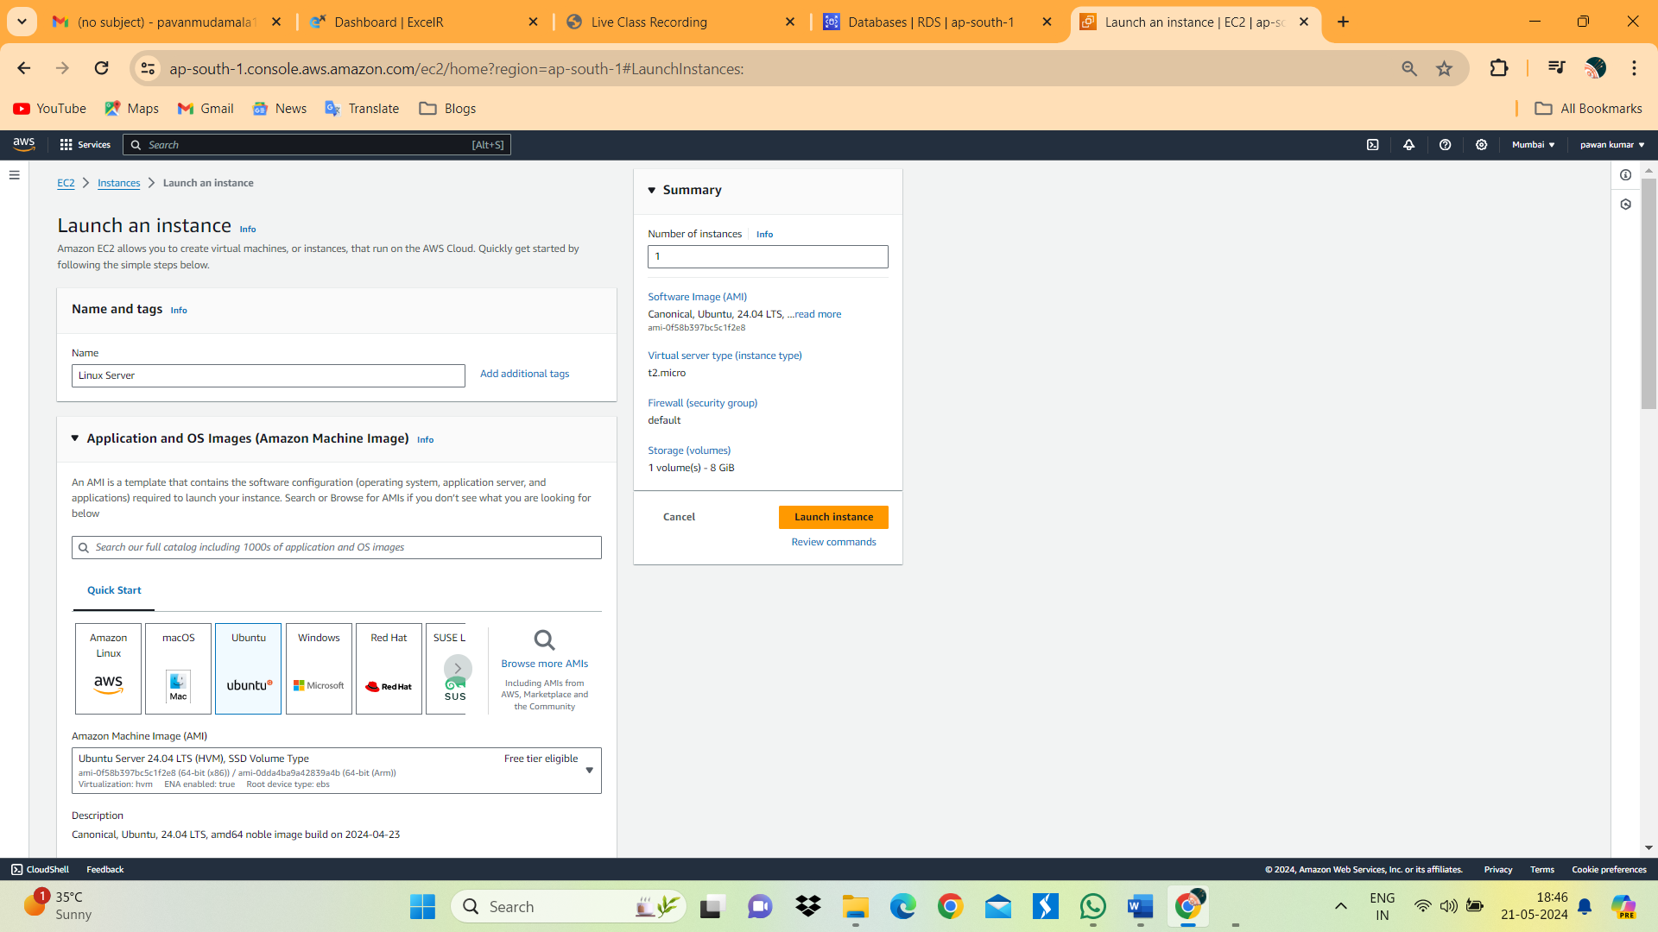

1. Below image we can see the Linux server EC2 instance.

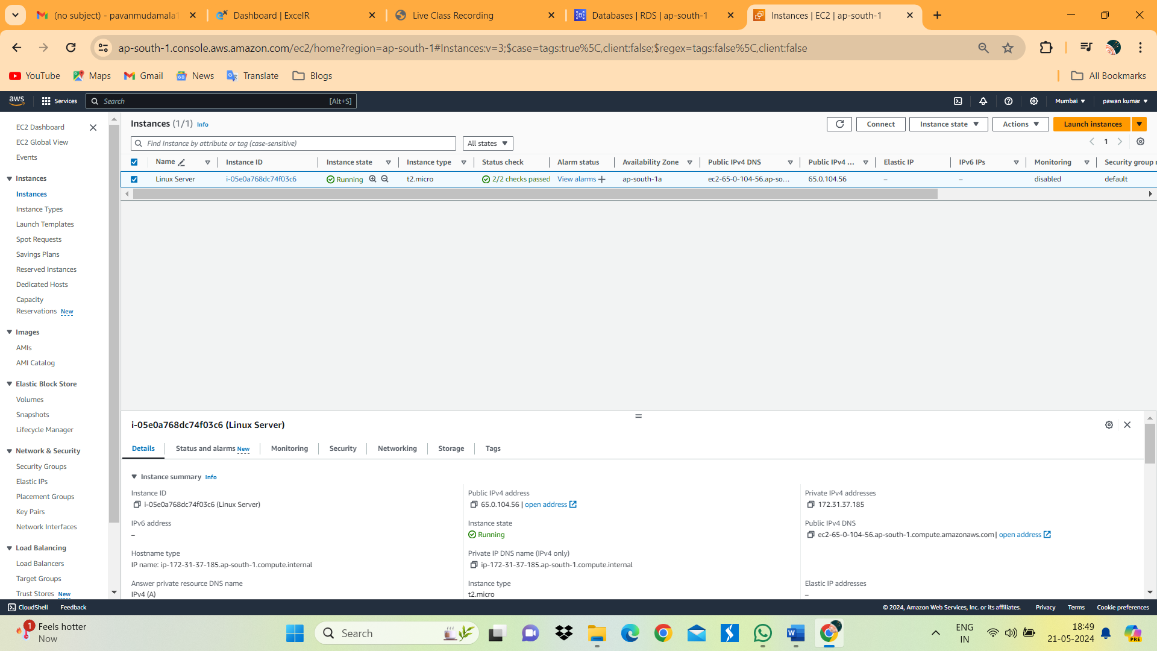

1. Connect Linex server and install MYSQL-server.

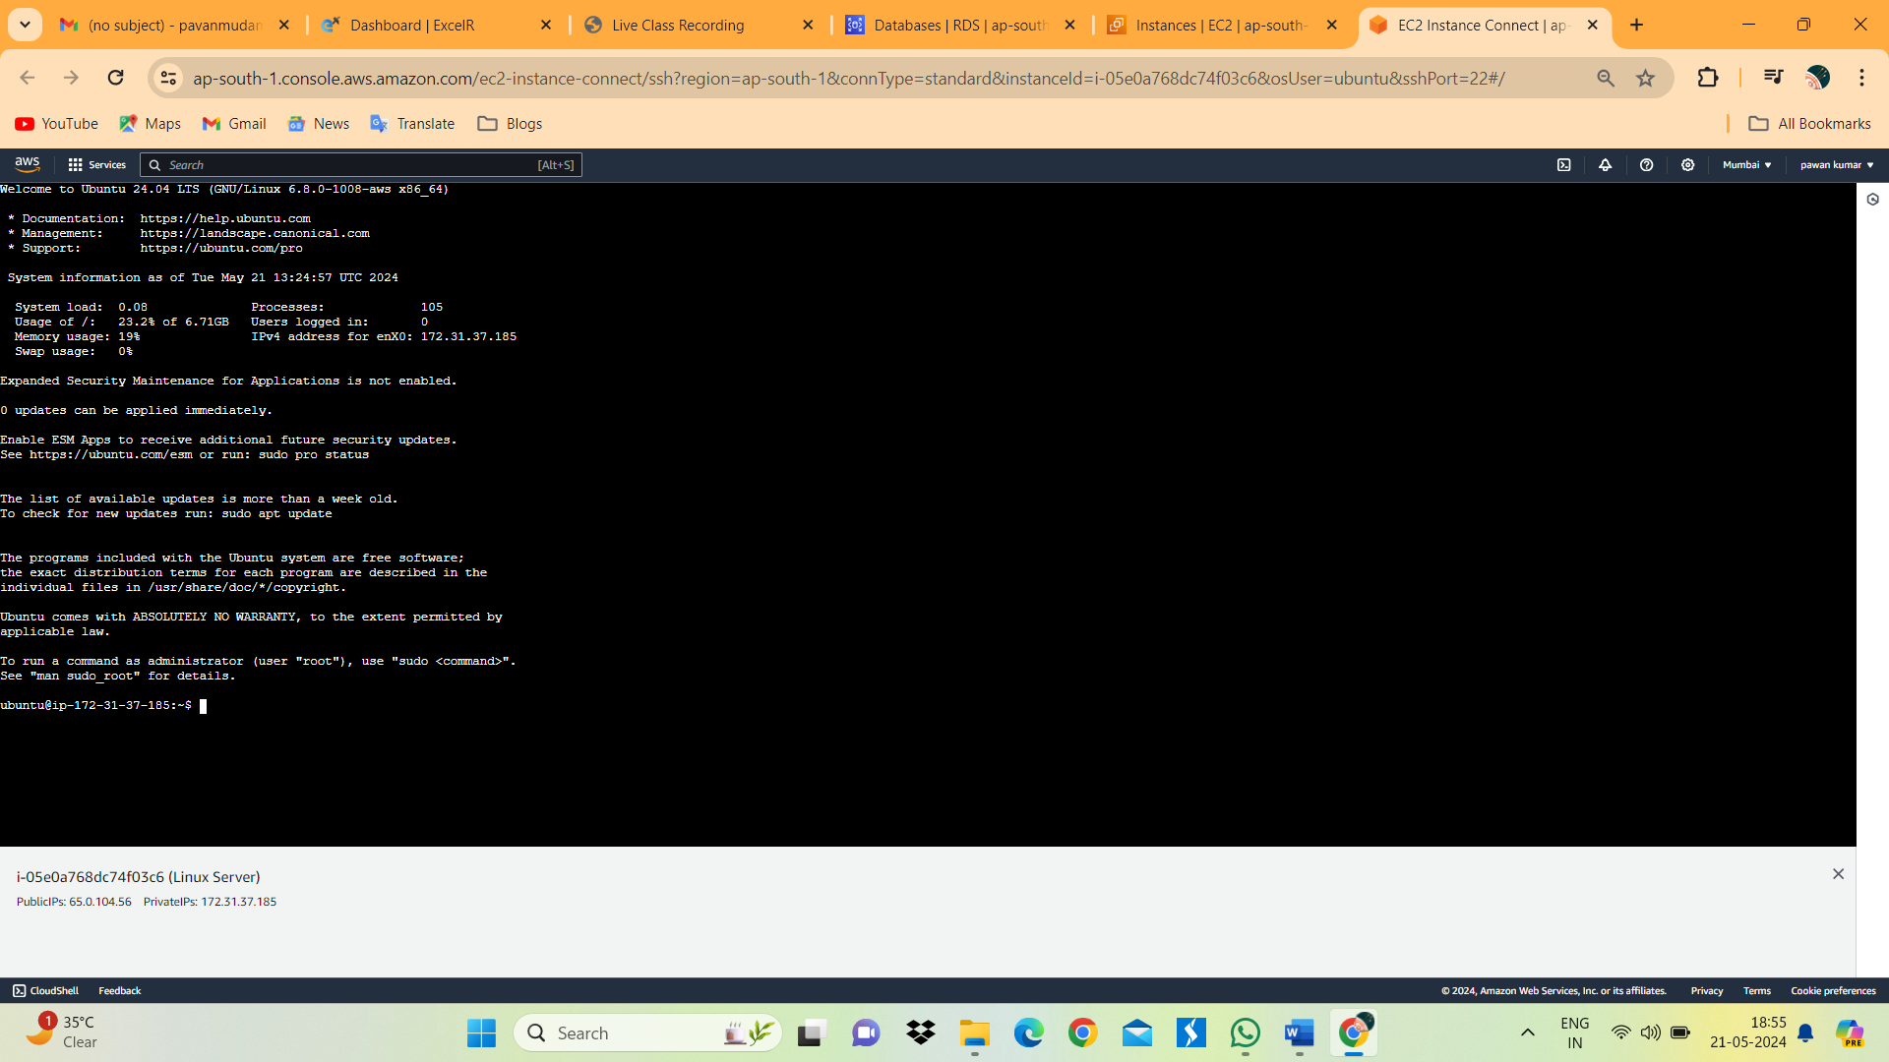

1. Service start Mysql. And below image we can see the status of Mysql.

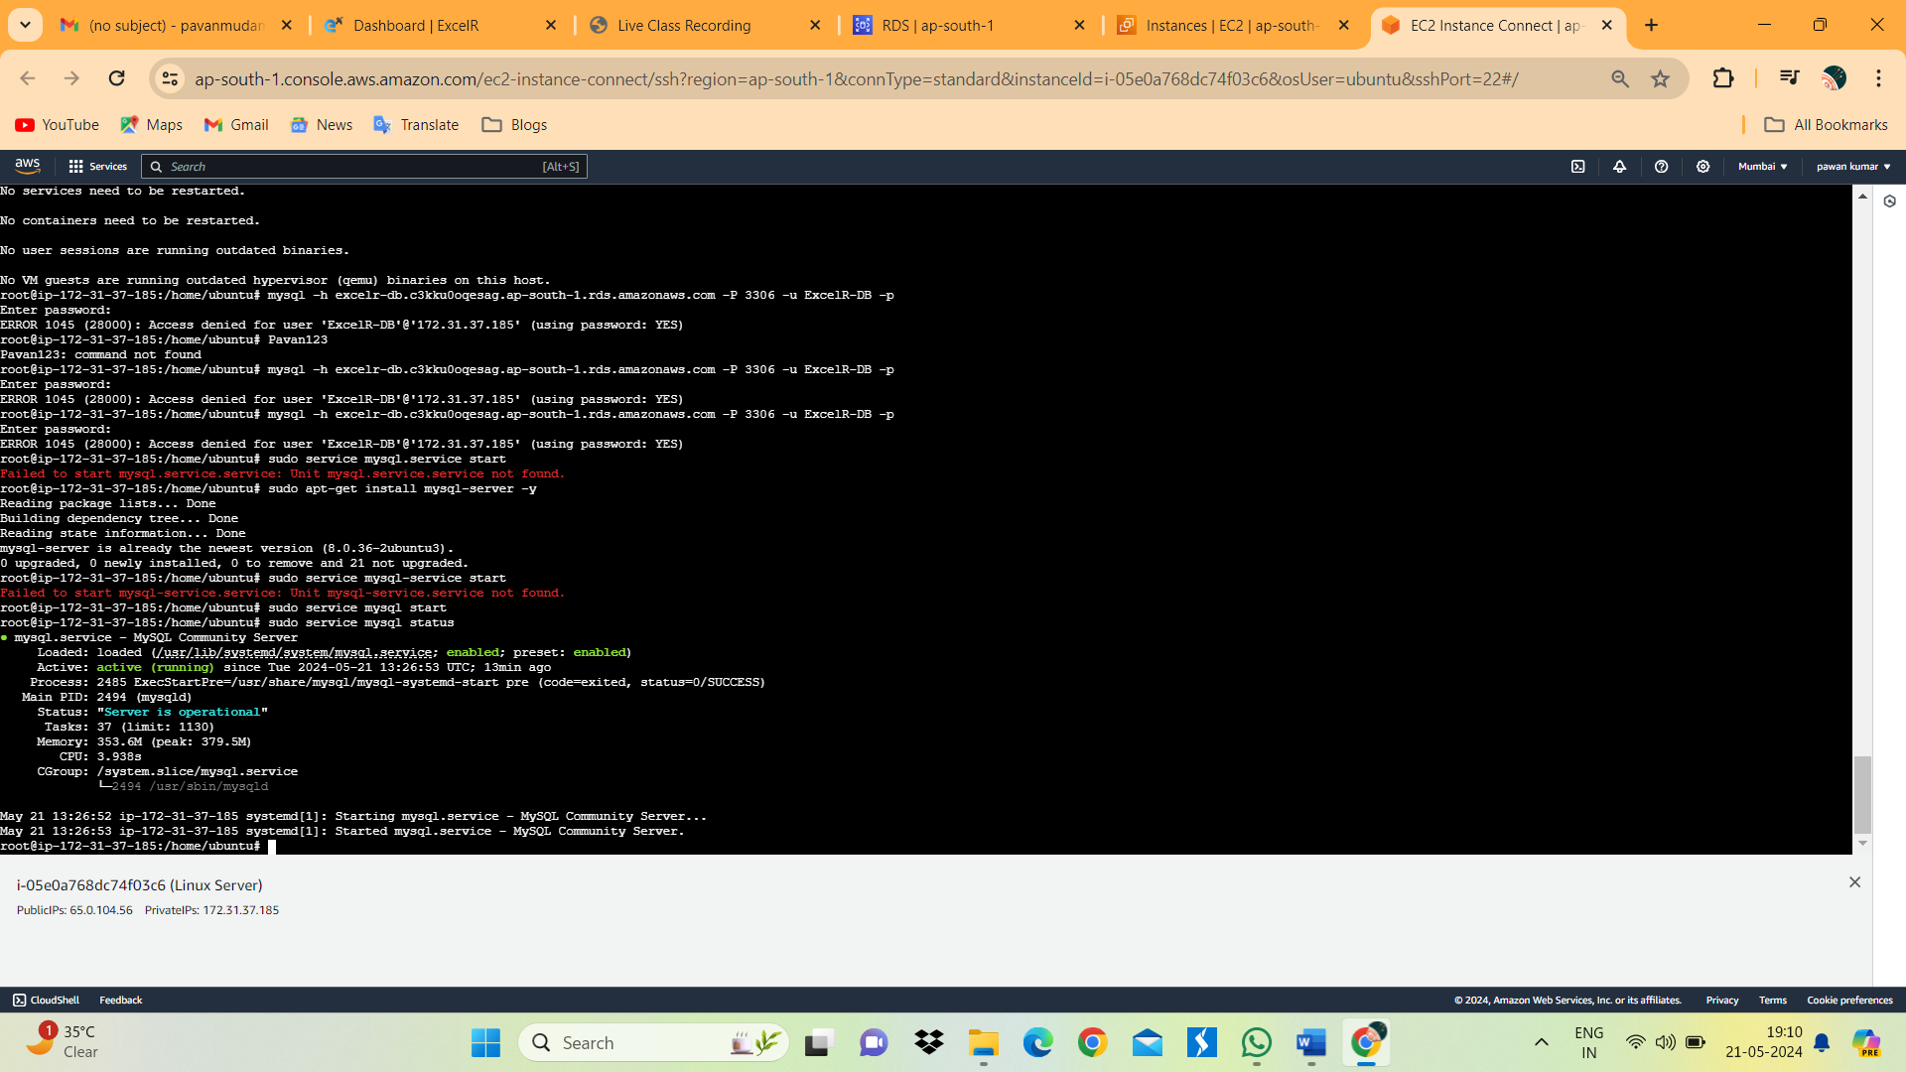

1. Connect MYsql Database which we launch in AWS by using End point ID.
2. Below image we can see the the MYSQL was connected.

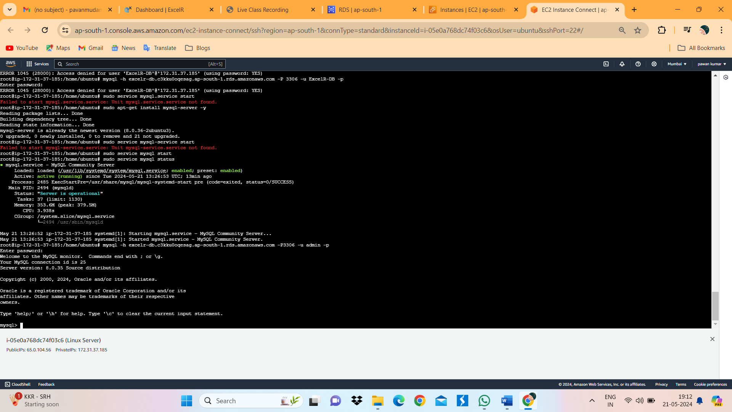

1. Create a sample data base excelrbd by executing Query Create database excelrbd;
2. Create a table Persons in excelrdb database.
3. Insert values into the Table.
4. Below image we can see the Table with values.

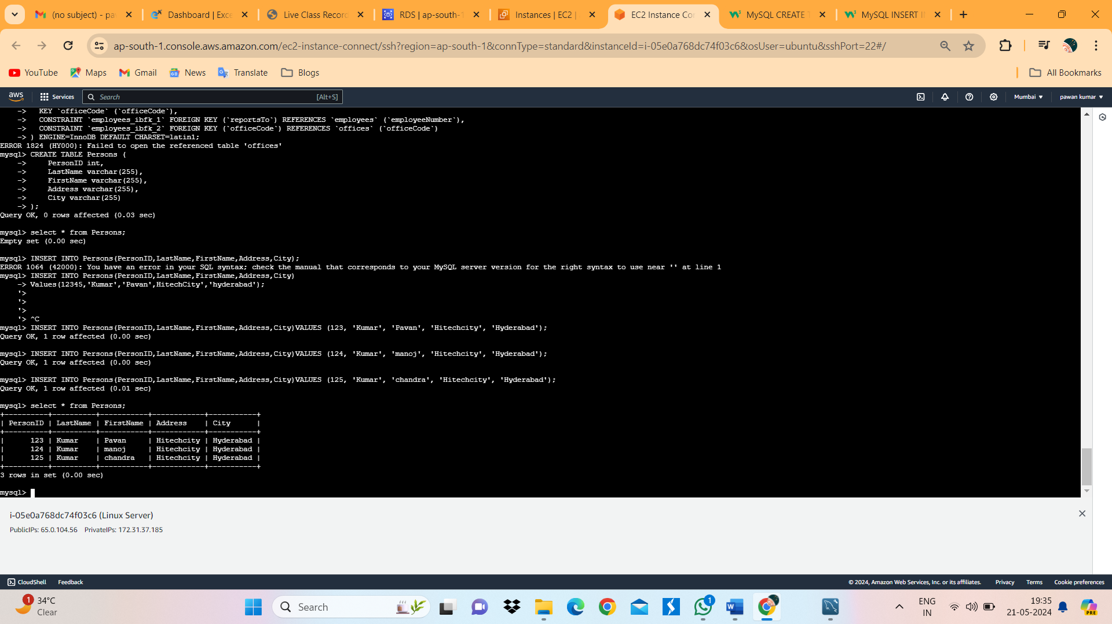

Steps to Create DynamoDB:

1. Search DynamoDB in Services. Click on Create Table.

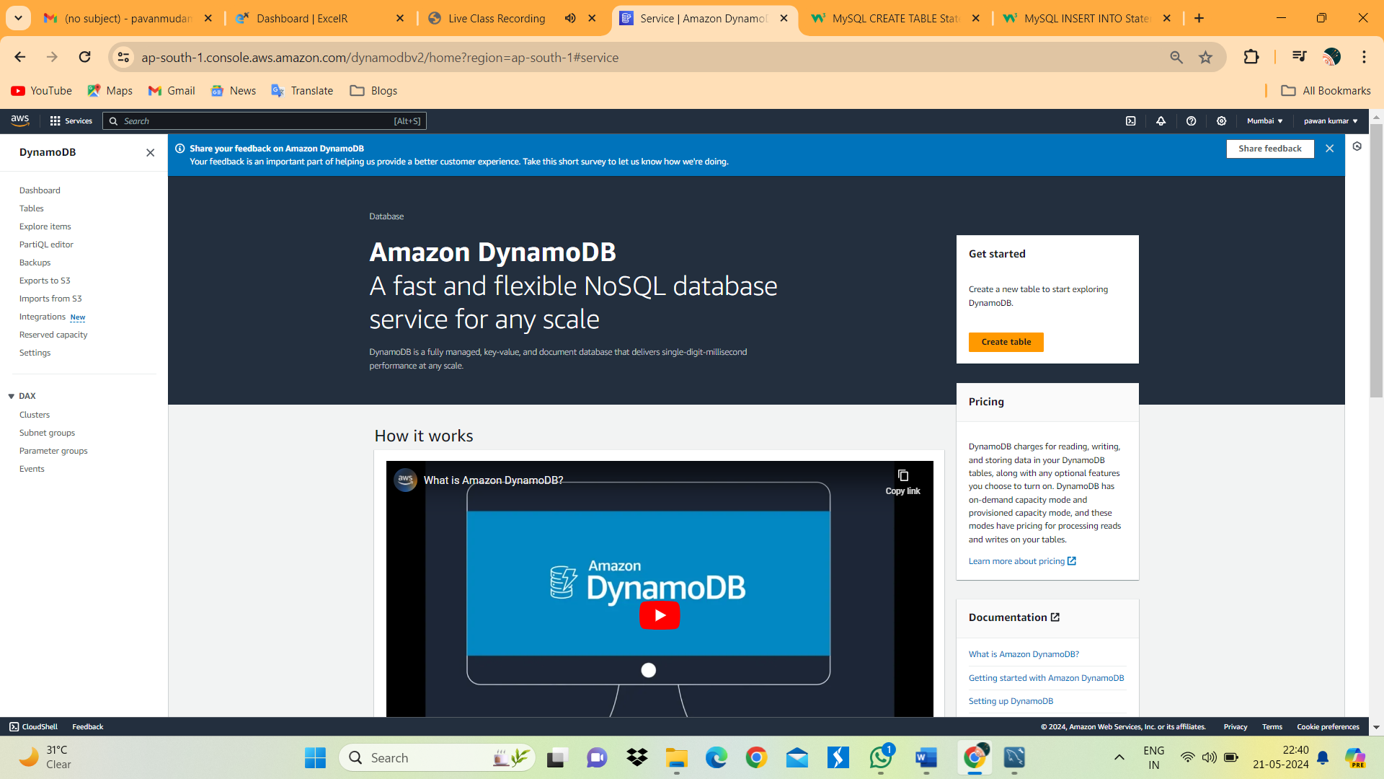

1. The New page will appears.

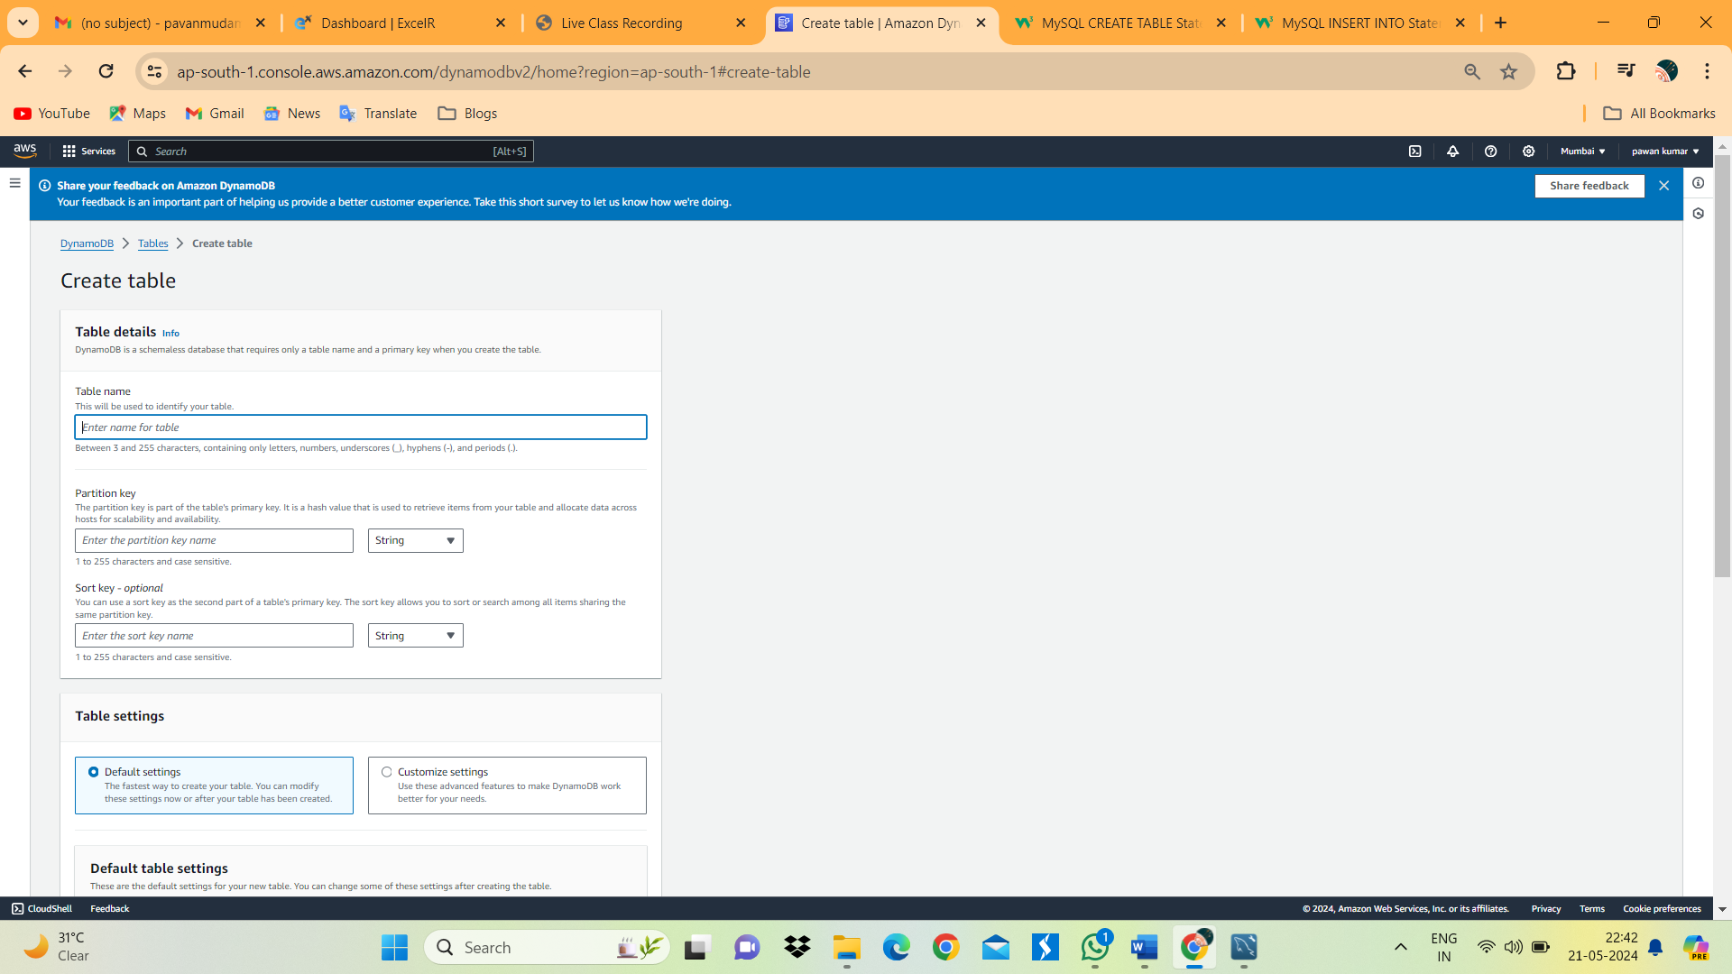

1. Give Table name as Population.
2. PartionKey As Country with String.

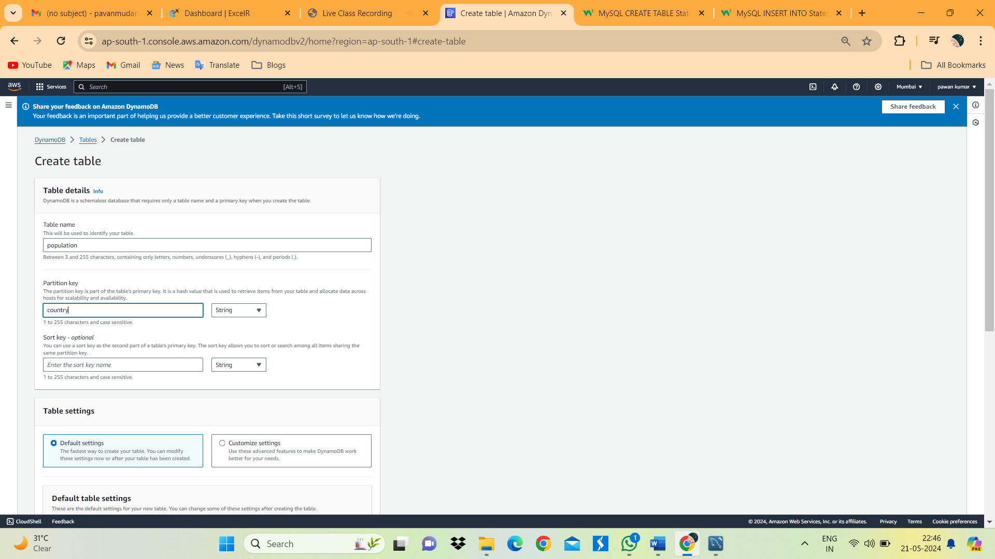

1. Click on Create Table.

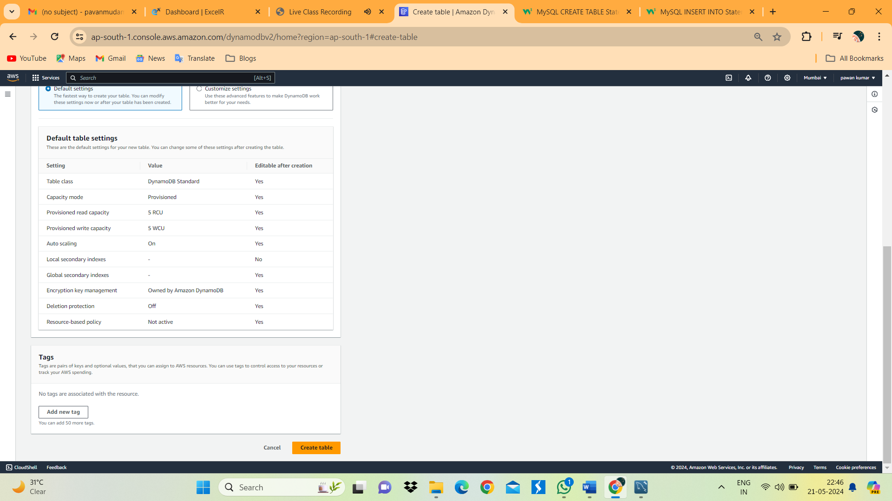

1. Click on Population Table.

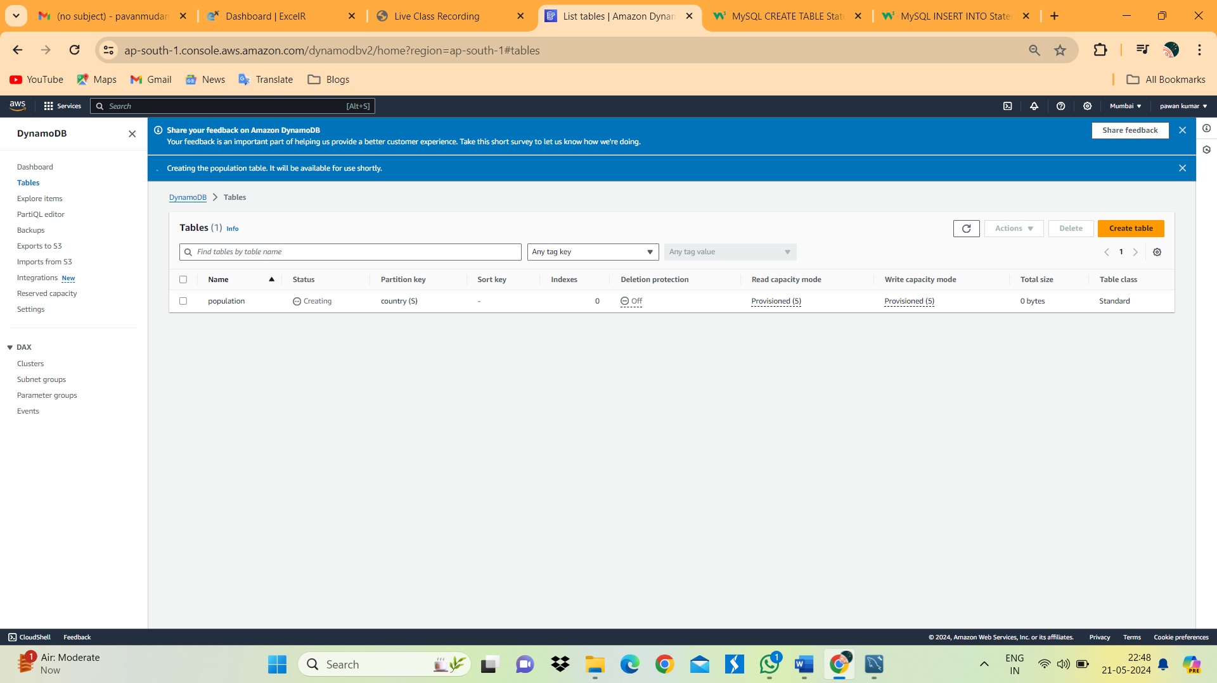

1. This new page will appears.

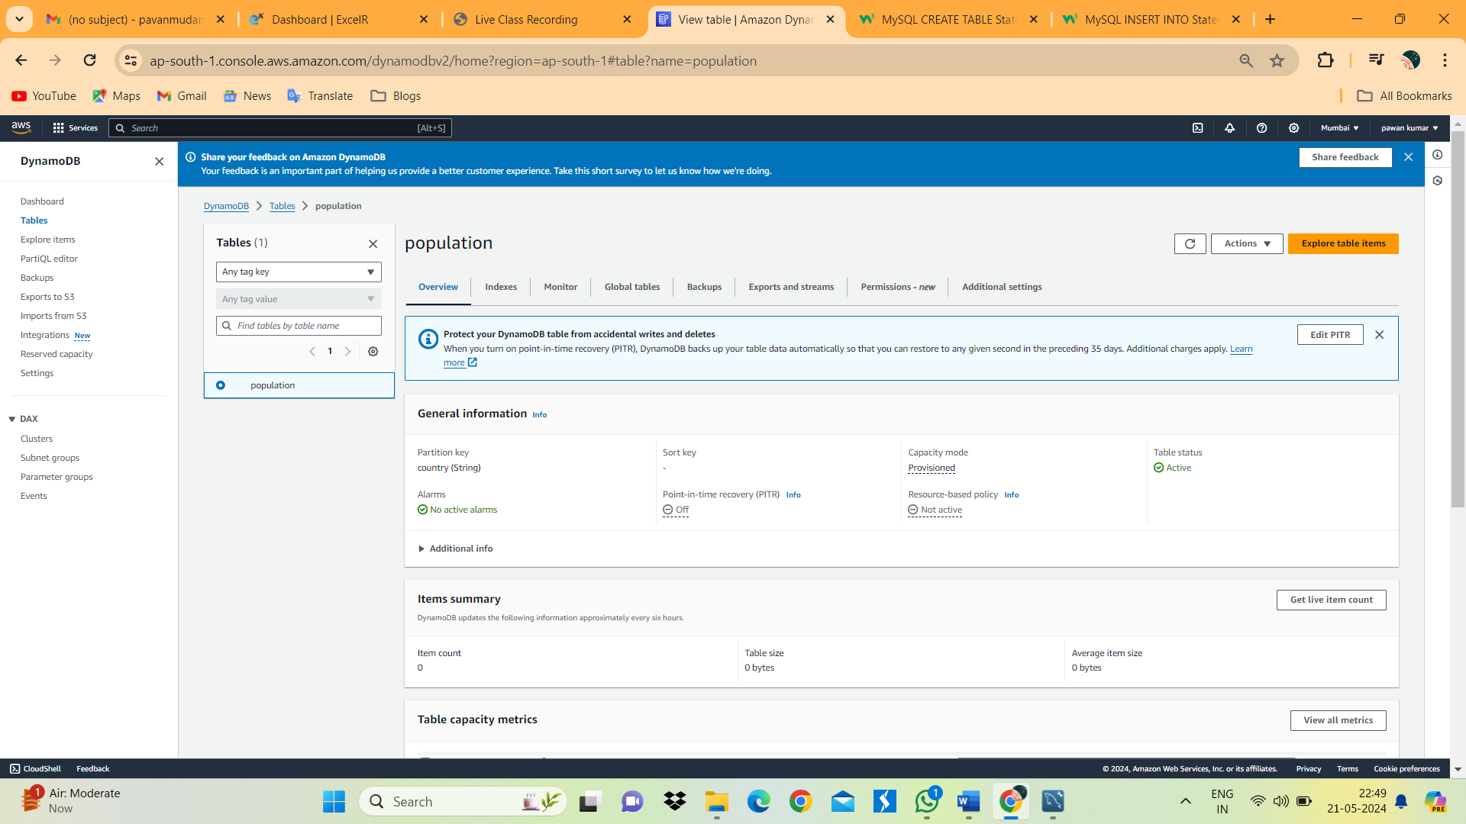

1. In Action Click on Create Items.

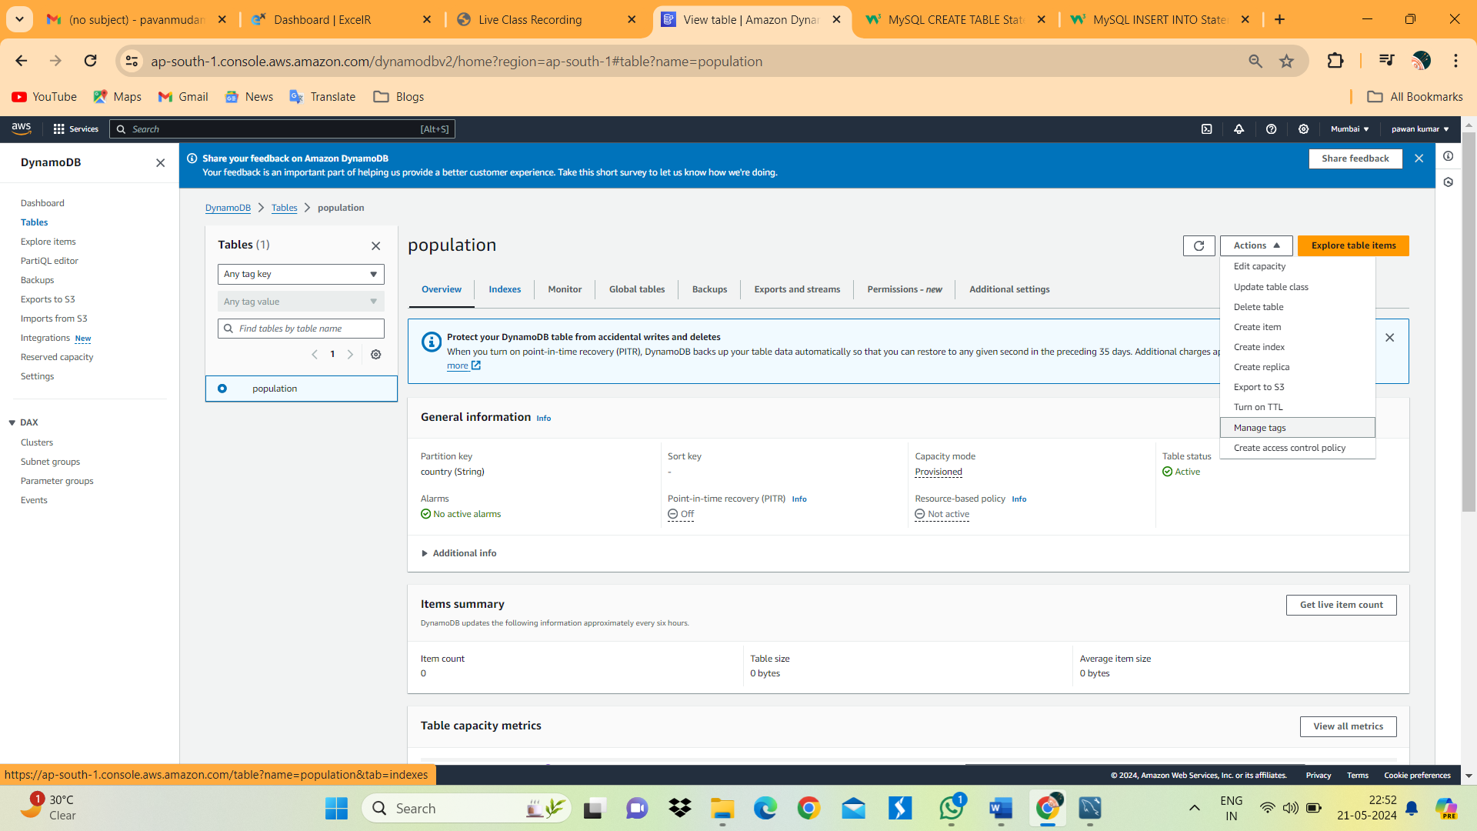

1. Give the Infor,mation that should be stored in table. I have Given some information which is shown in below image. Then Click on Create items.

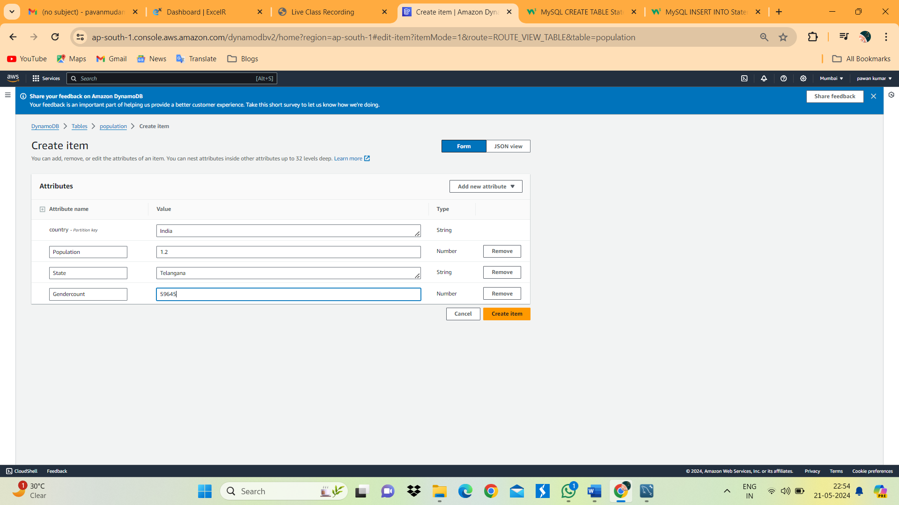

1. In below image we can see the table information.

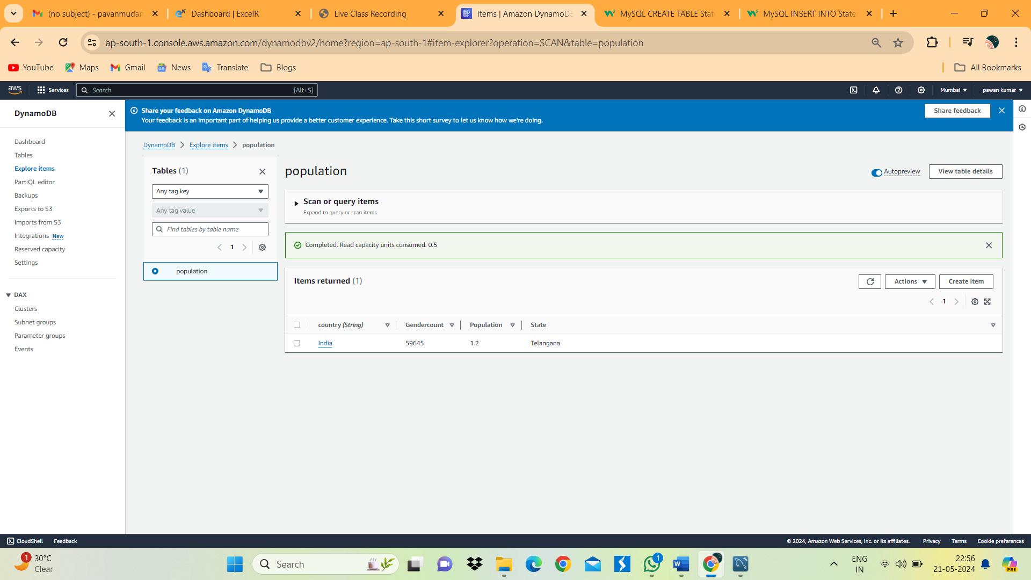

1. In items referred in Action tab Download results to CSV. By clicking this we can download the CSV file. Of table information

